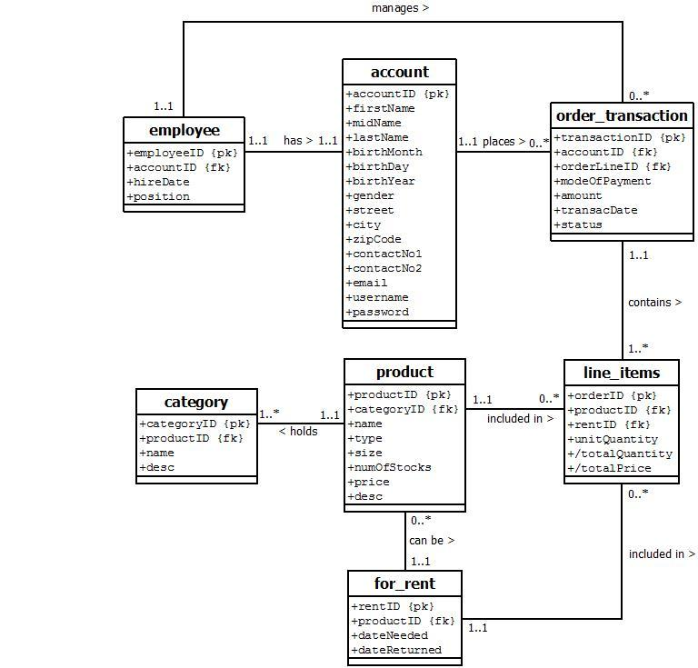

Crossover Costumes’ Sales Transaction System is used to track records of its clients, which include the unique account ID, client name, birthday, address, contact numbers, email, username, and password. Employee has also an account to manage the transactions, which include the unique employee ID and position.

Crossover Costumes maintain an inventory of the products that it sells. For each product, the following are recorded - the unique product ID, product name, sizes, product type, unit price, quantity in stock, status if the product is available or not, and product description.

Registered clients can place orders for products with Crossover Costumes. For each order transaction, the system tracks the unique transaction ID, date of transaction, date of delivery, total amount, and status (i.e., approved or disapproved). Each order can contain numerous products or for rent products (or commonly referred to as line items). Each line item records the quantity ordered and the unit price for each product included in the order transaction. The total amount of an order transaction is calculated from the sum of these individual line items (quantity ordered * unit price).

Once an order has been purchased, the quantity in stock for the product is reduced. Daily, weekly and monthly sales transaction reports are generated by the system based on these records.

//Contact numbers should be a multi-valued attribute.

//maybe add a dueDate because if the dateReturned is late, they have a fine right? or no? but I’m sure dateReturned and dueDate are separate.

//Separate the relationship of product and for_rent, and rename product to “for_sale”. Copy the attributes from “name” to “desc” to for_rent.

//Remove attribute “Size”, since all types of clothing have only one size.

//Di ba baliktad yung multiplicities nung sa product(1..1) and line_items(0..*)? - Ibig sabihin neto isang product pwede sa maraming line items… shouldnt it be the other way around? pano if the customer wants to buy more than one item?

//the multiplicity of product > client seems to be wrong. 1...1 product holds many categories. shouldn’t the category hold many products?